**LOGISTIC APP DOCUMENT**

**COMPANY USER**

1. 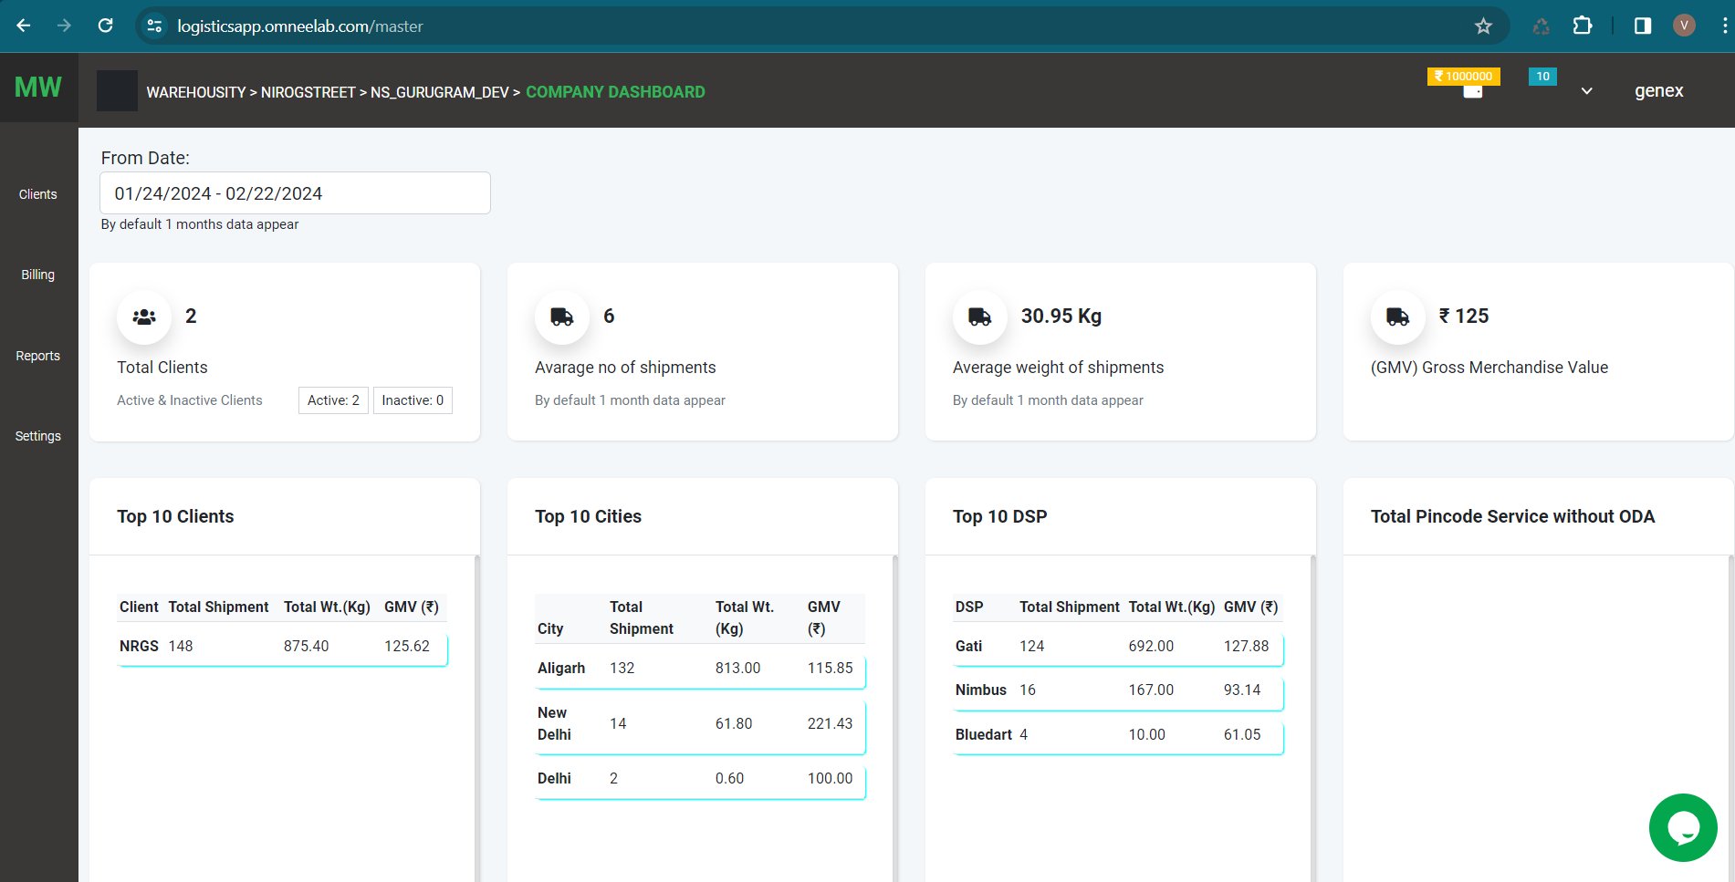**Company Dashboard**

In this dashboard, we have details of all clients of a company.

1. Total Client – total no of active and inactive clients of the company
2. GMV: Gross Merchandise Value = Total shipments value / Total no. of shipments
3. Below detail changes according to the date filter (by default 1-month data appears)
4. Average no of shipments, Average weight of shipment,
5. Top 10 clients who got the maximum no of orders, the total weight of shipments, GMV of particular time of period.
6. Top 10 Cities, maximum no of order, the total weight of shipments, GMV of a particular time of period.
7. Top 10 DSP, maximum no of order, the total weight of shipments, GMV of particular time of period.
8. Total pin code service without ODA
9. **User Profile:**
10. 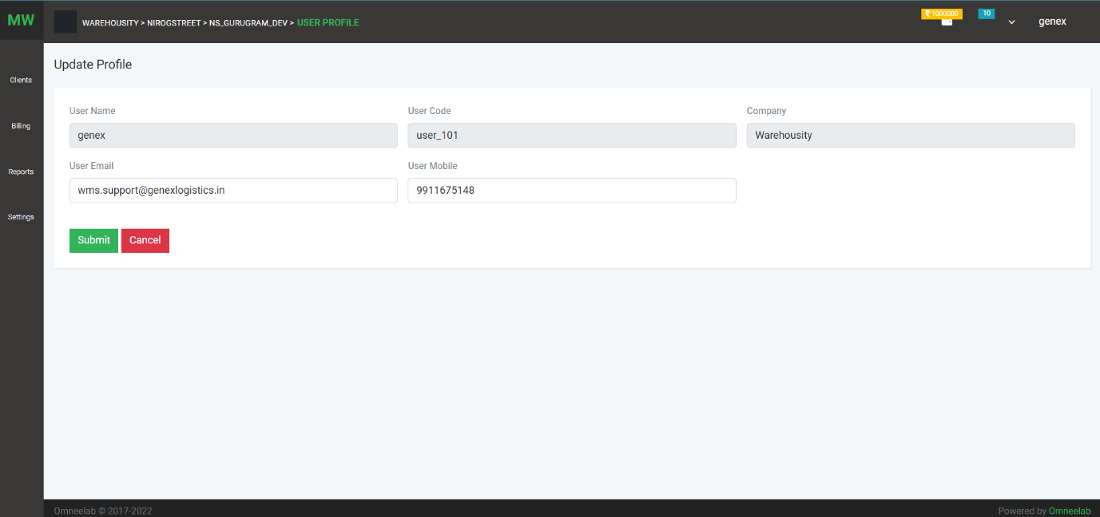Use can update profile
11. 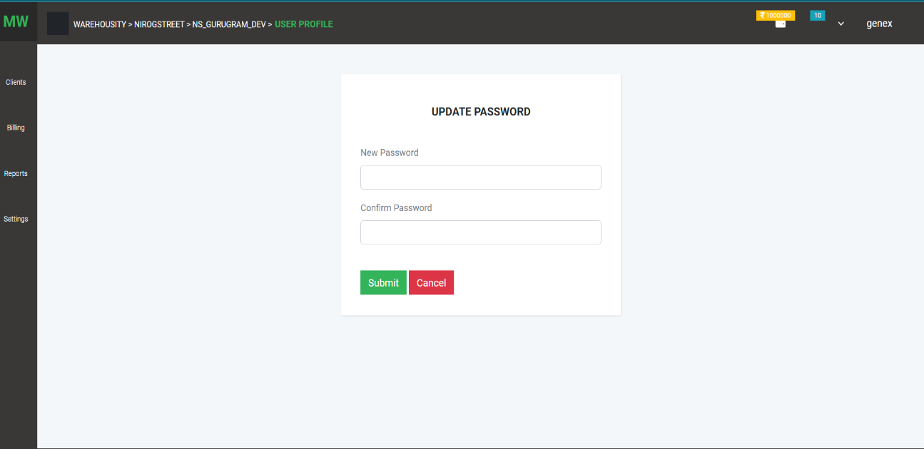Change Password:
12. Company profil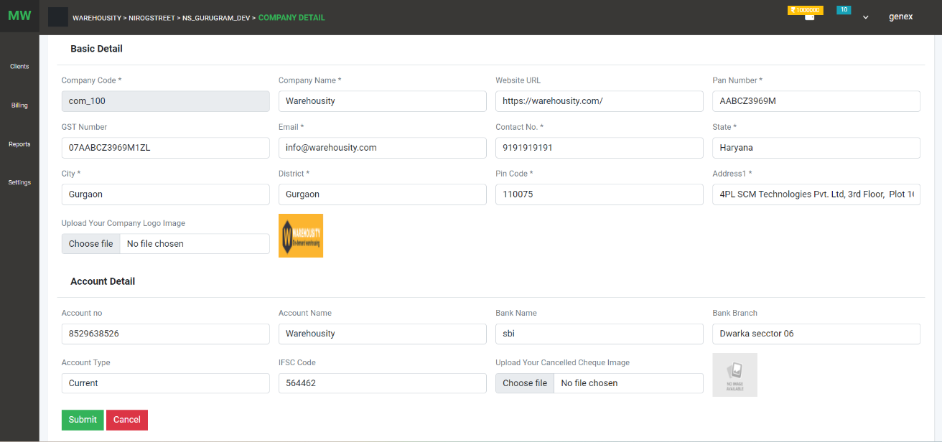e

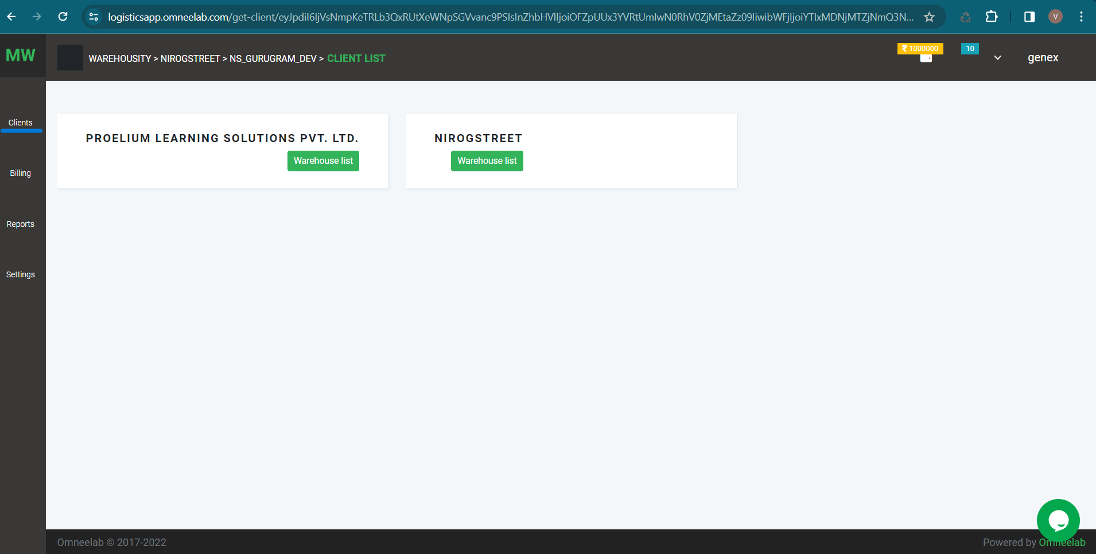**CLIENT LIST**

On this page, user can see a list of clients

1. Click on the client name, user can see the client's detail
2. Click on the warehouse list we can see the warehouse list of that client.

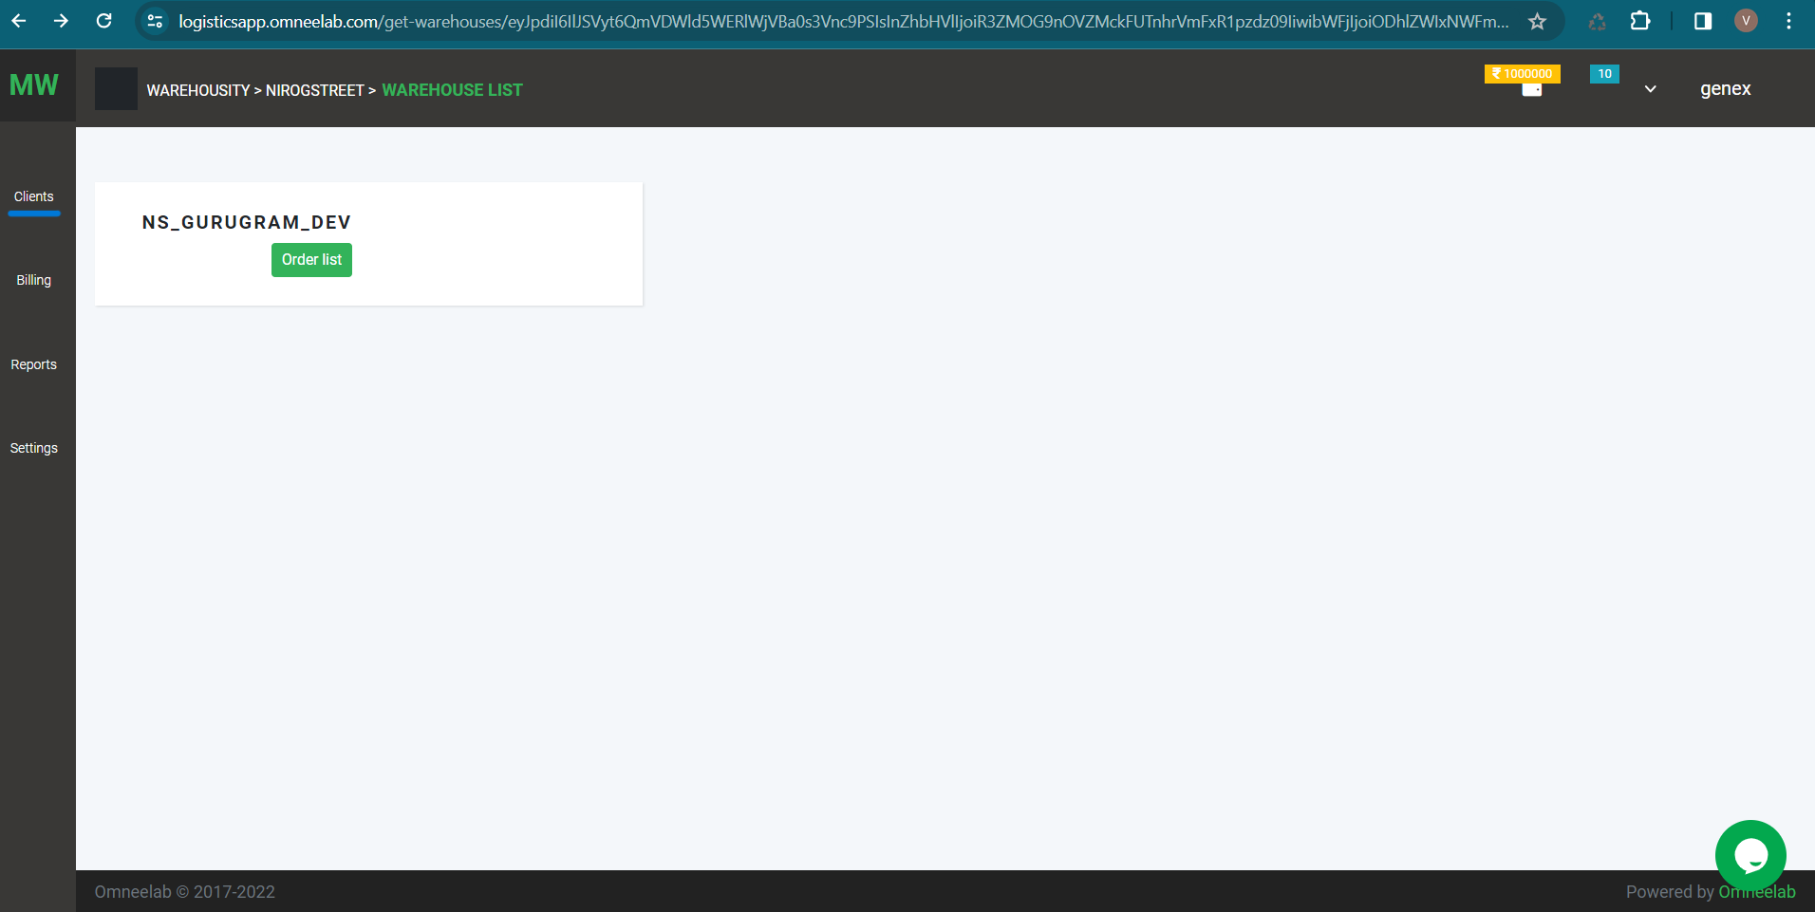

On this page, user can see a list of warehouses

1. Click on the warehouse name, user can see the warehouse detail
2. Click on the order list we can see the order list of that warehouse.

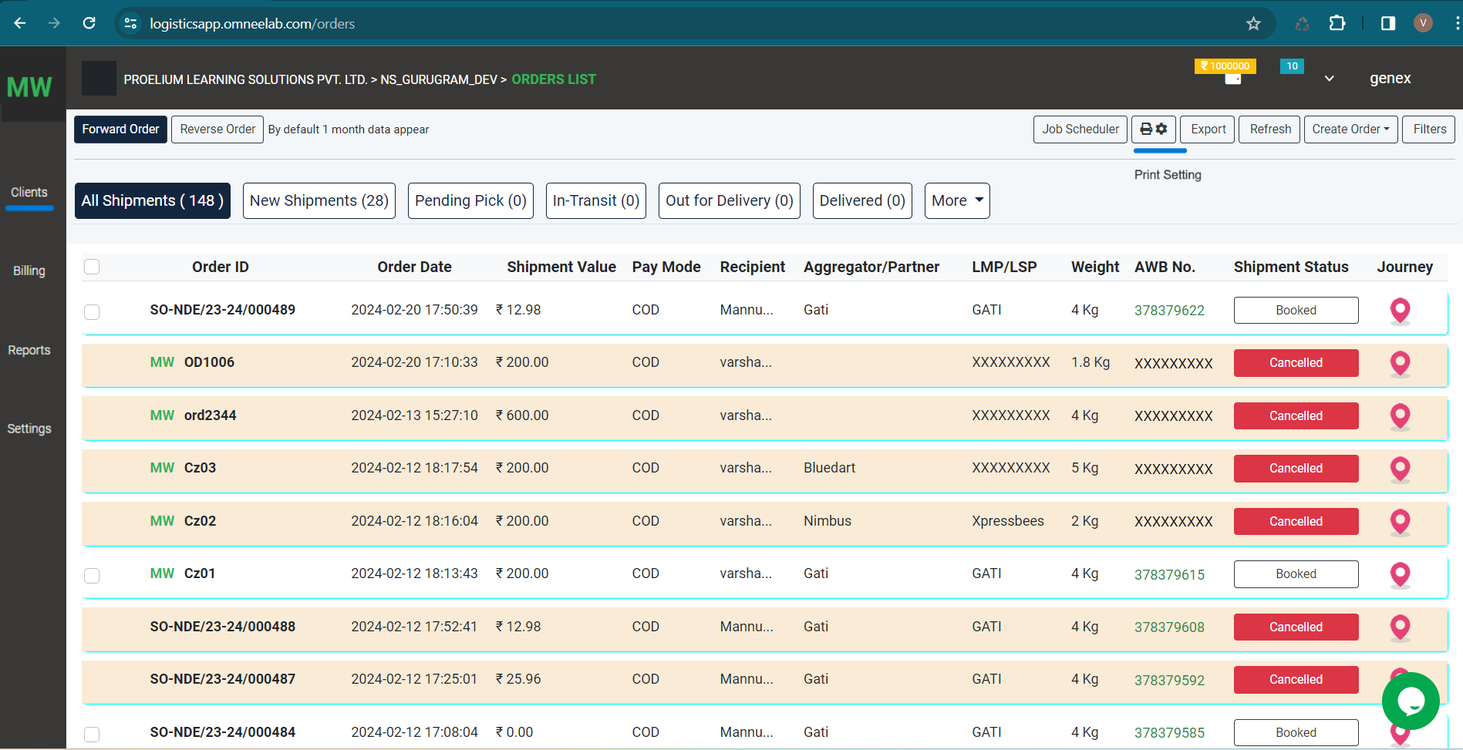

On this page, the user can see a list of Orders

1. Two types of orders Forward Order and Reverse Order
2. Job Scheduler – New orders will be cancelled when no activity is performed within two hours
3. Print Setting - user can set label print setting that will apply to the label
4. DSP Selection on booked status on manual order

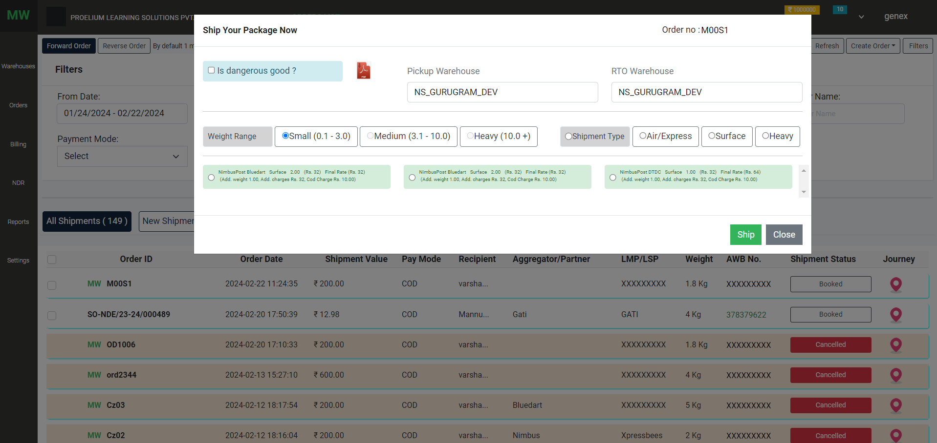

1. Tracking: The user can track order detail

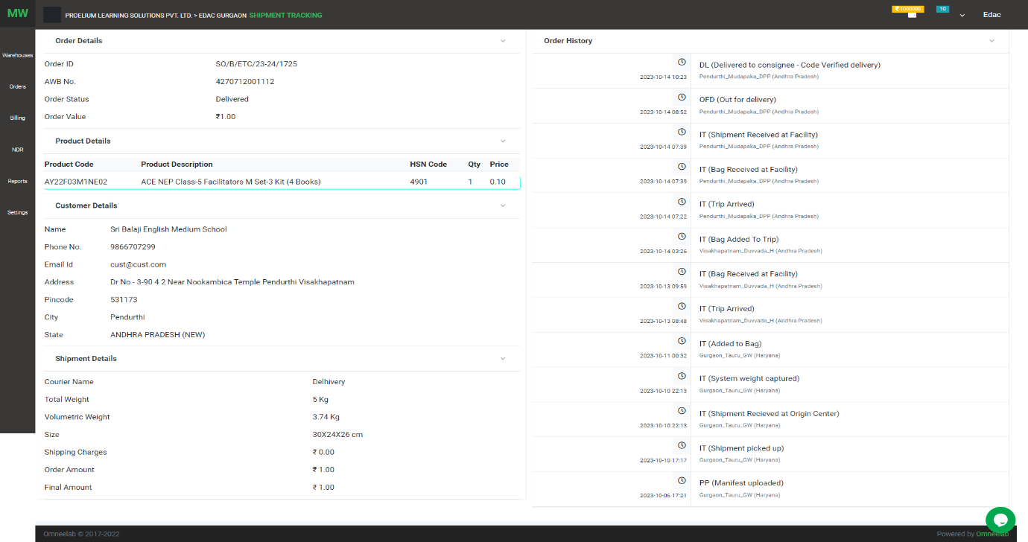

Click on AWB no tracking page

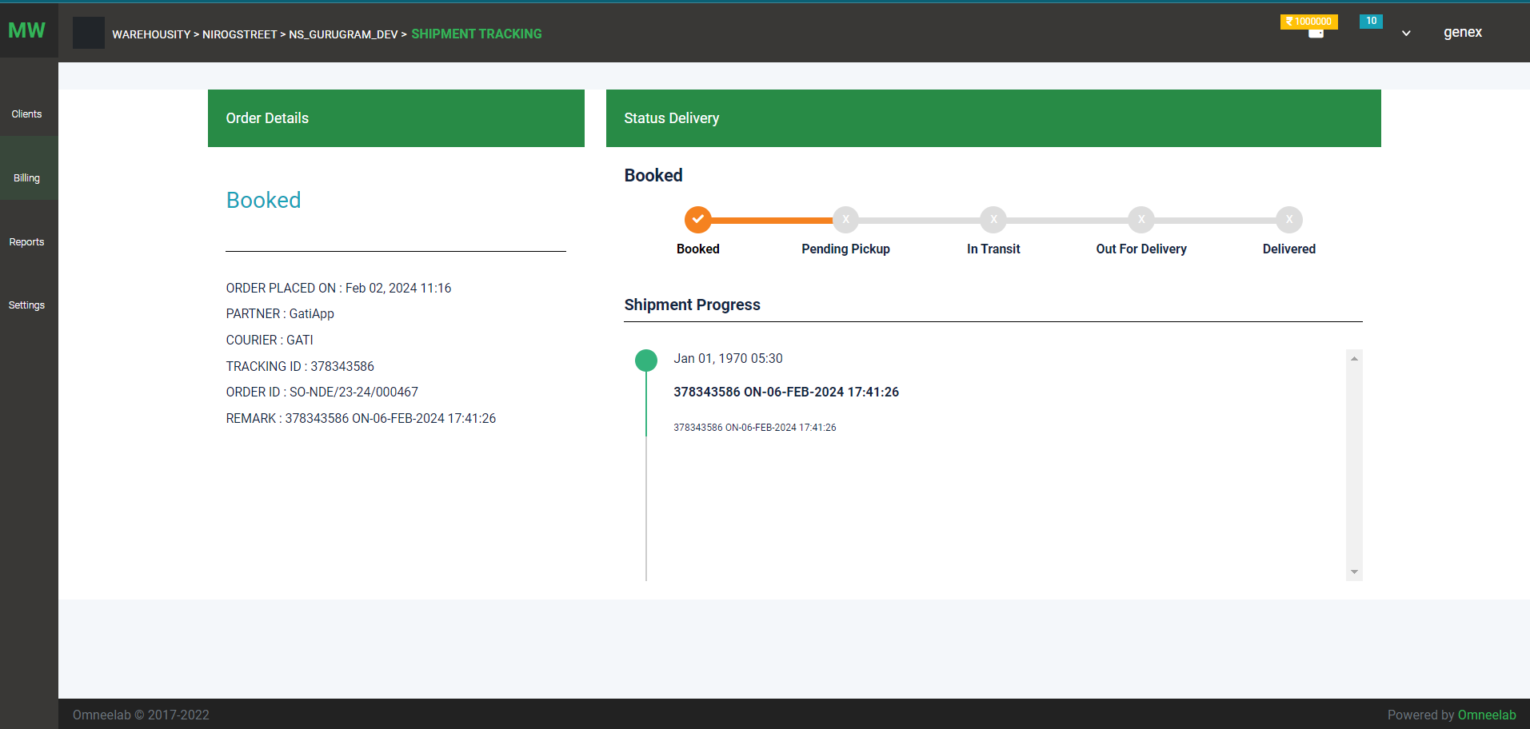

1. Create order - manual order creation

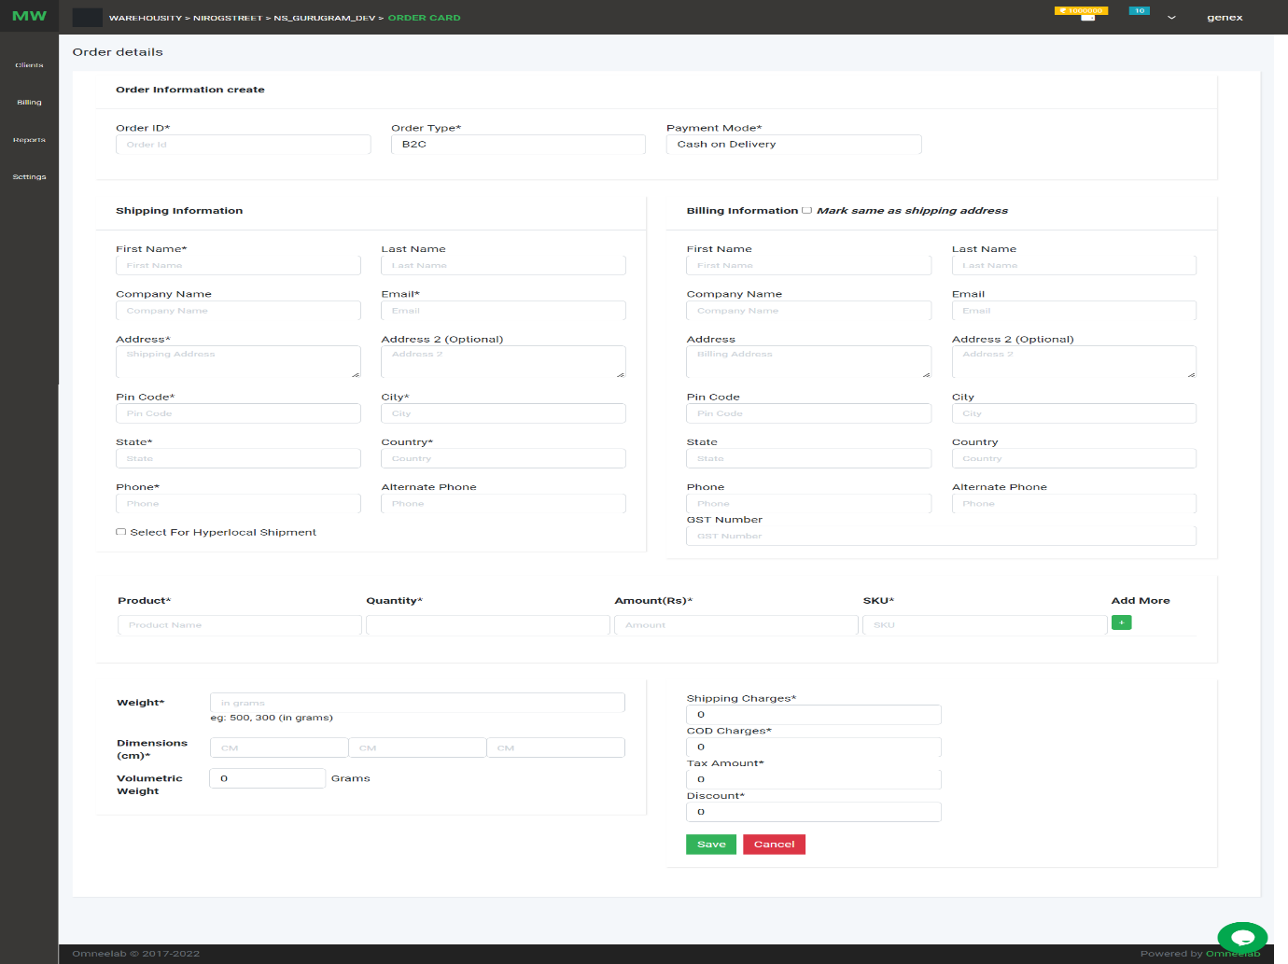

1. 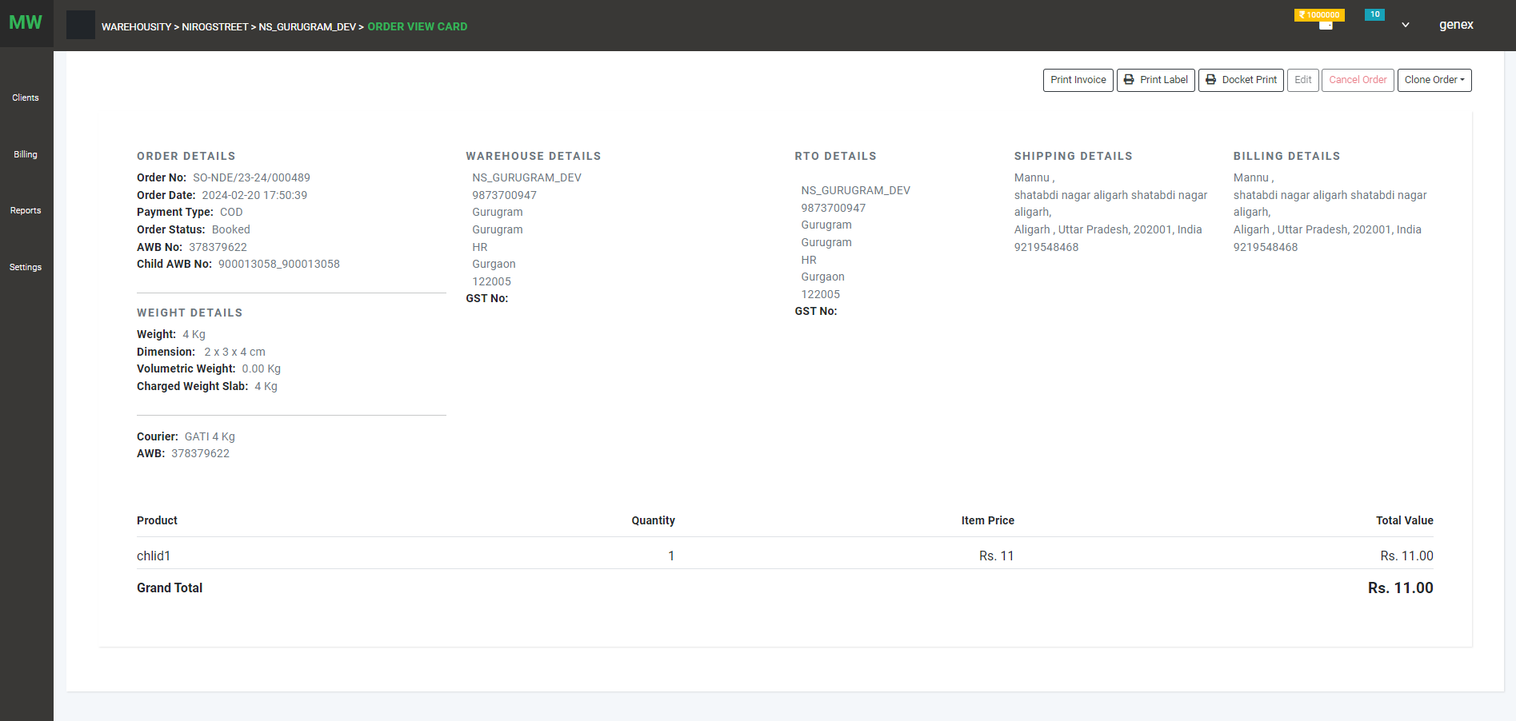Order detail view page

Option shown on this page:

1. 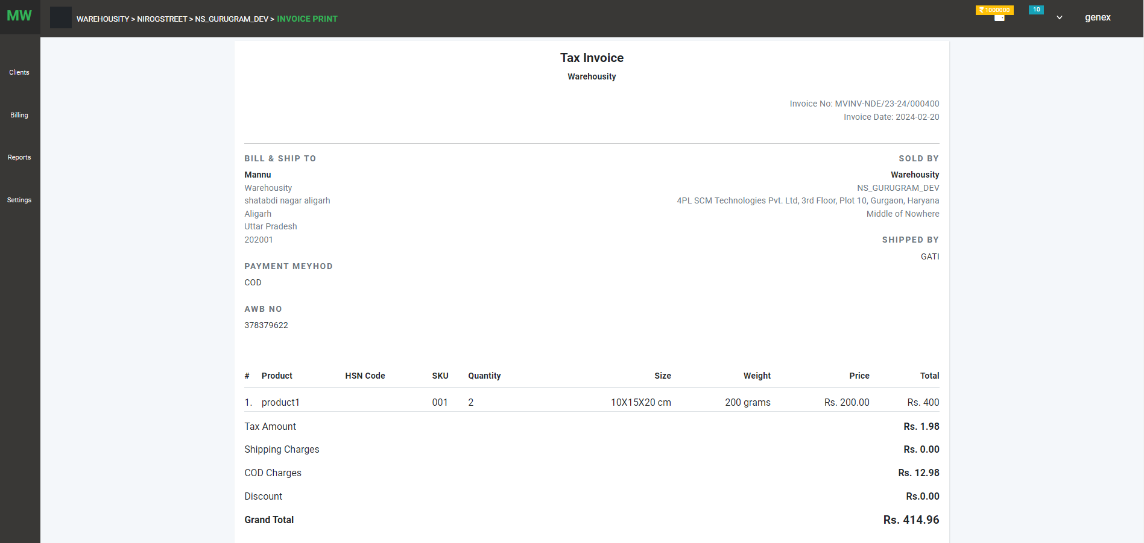Print invoice : order invoice include order detail, consignee detail ,product detail
2. Print label : download packing ship against order
3. Docket Print: download docket detail like awb no against order
4. Edit Order : user can edit order before ship status on manual order
5. Cancel order : user can cancel order before pending pick status
6. Clone Order : user can repeat order using clone option

**SETTING:**

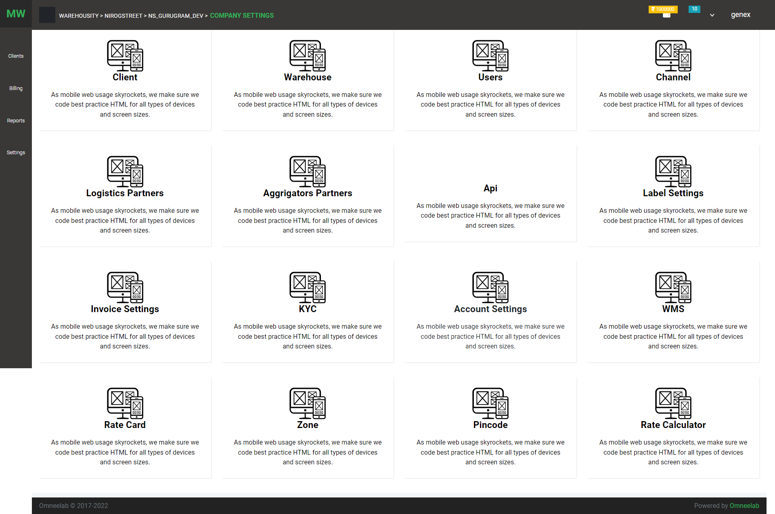

1. Client: This option has a client list and creates option

List page

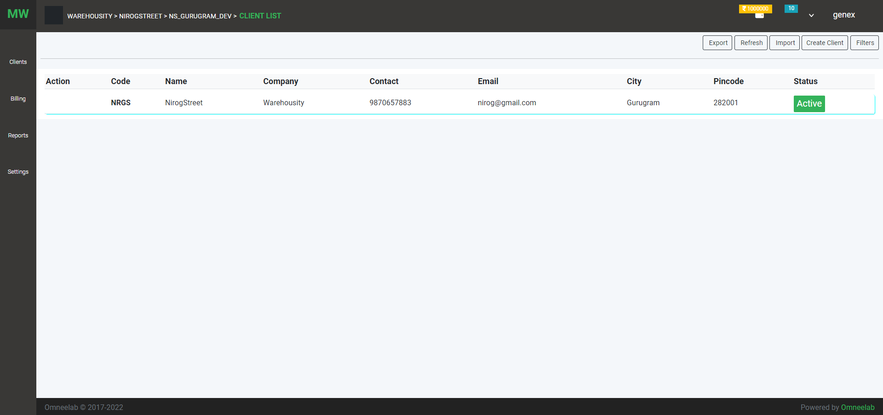

Create page

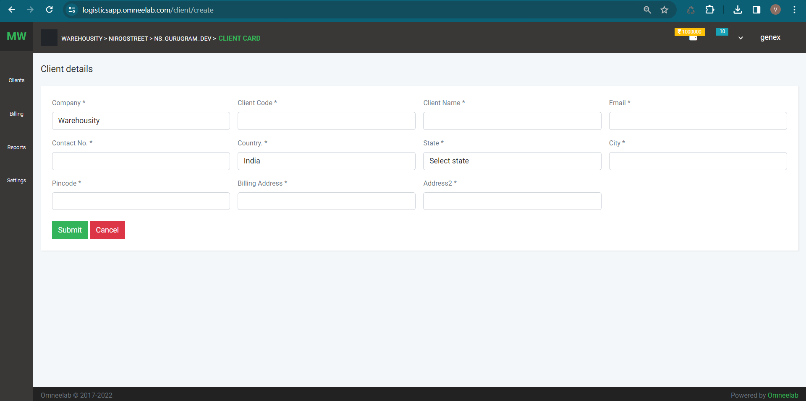

1. Warehouse: This option has warehouse list and create option

List page

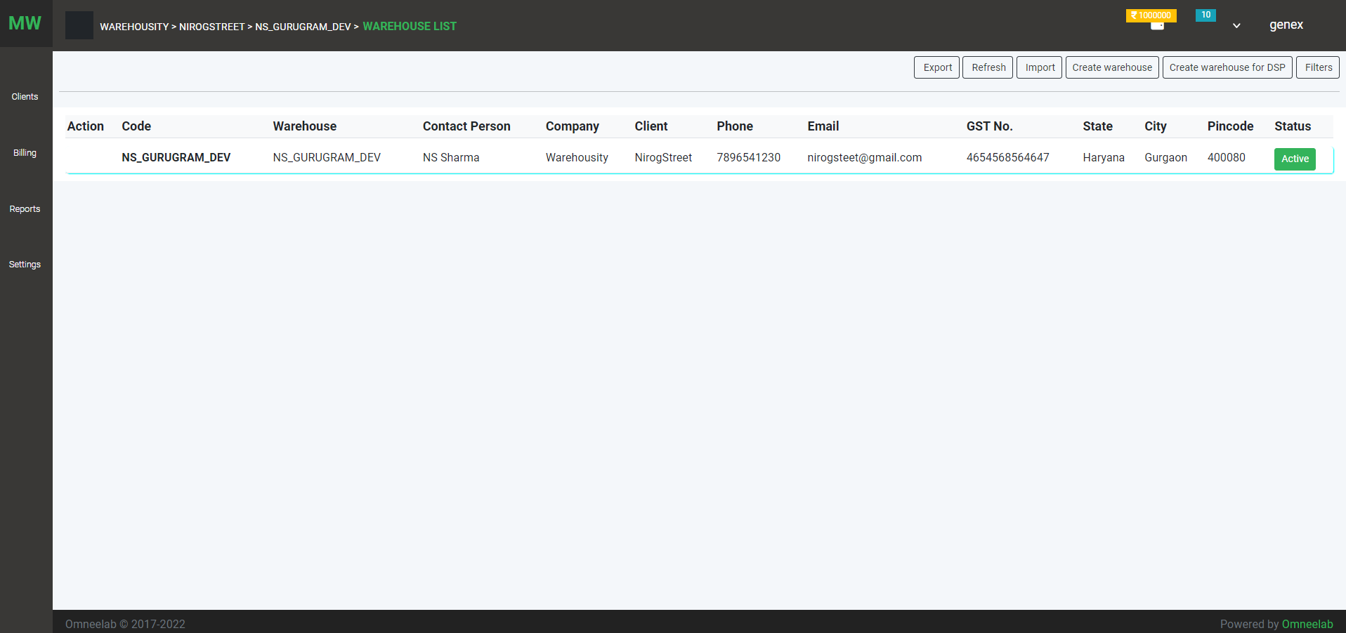

Create page

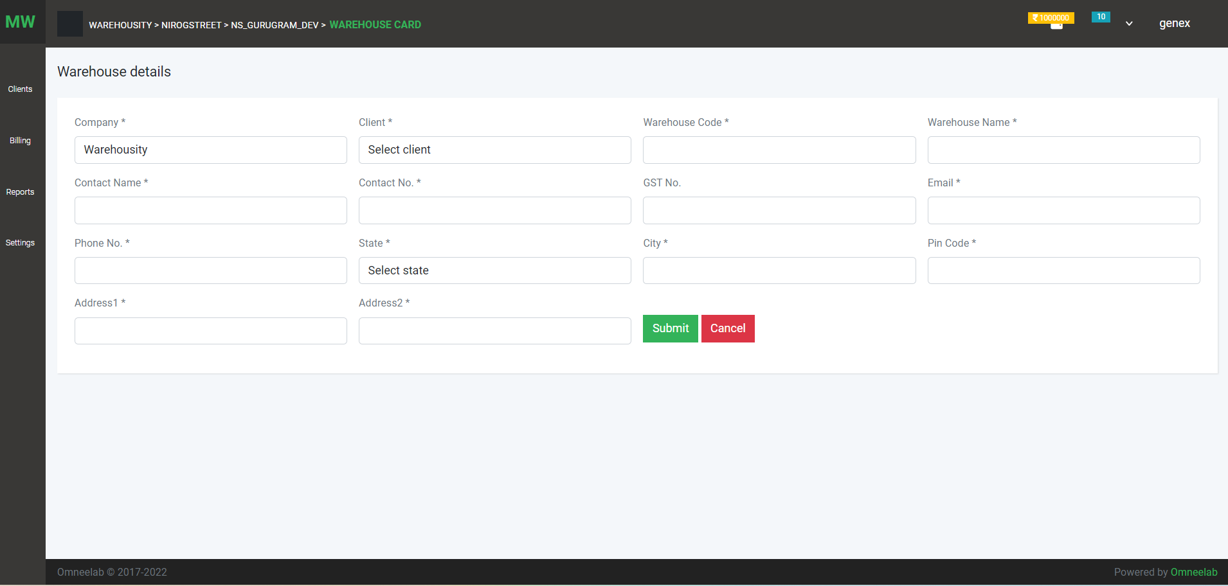

1. User: This option has a user list and creation

List page

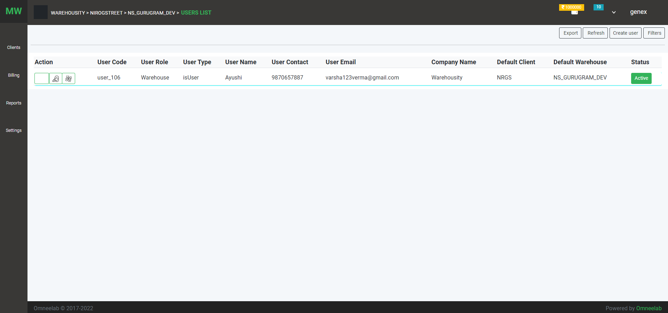

Creation page

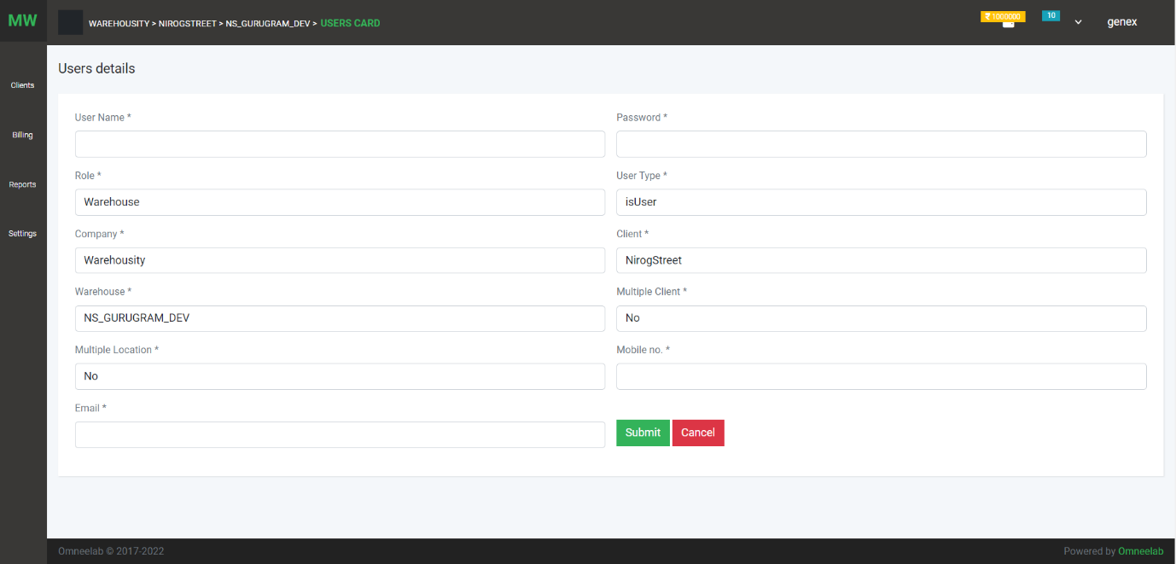

User permission page: The company giver permission to the user for particular options (like edit, create, delete, download, print)

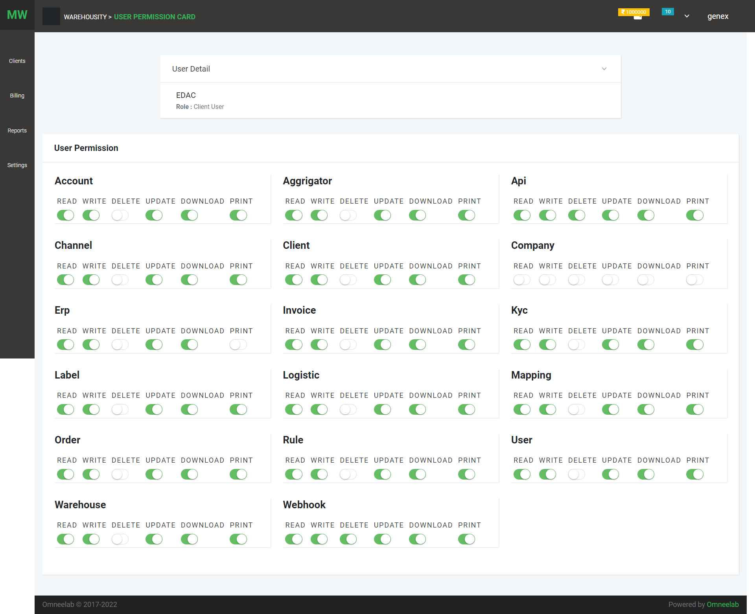

User warehouse mapping page: In this user can access the warehouse of a particular client

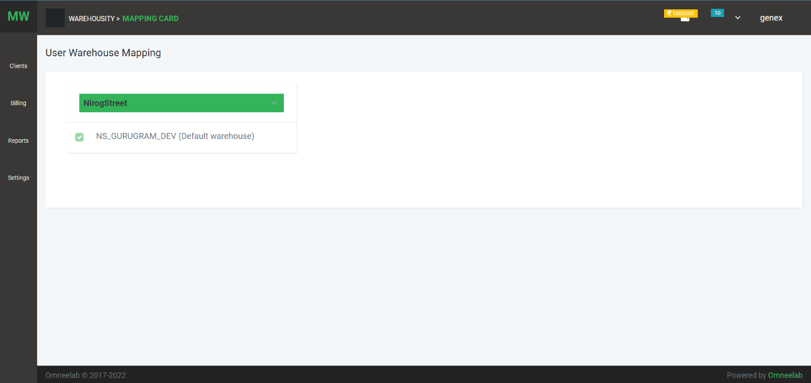

1. Channel partner: channel partner list

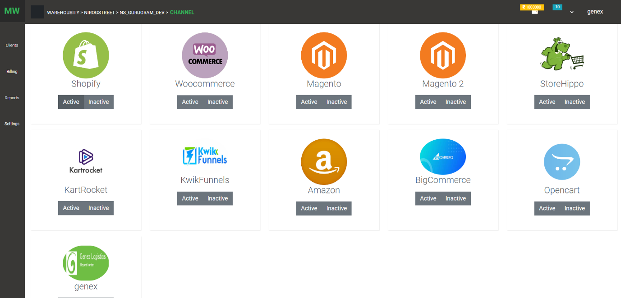

1. Logistics Partner: list of logistics partner

List page

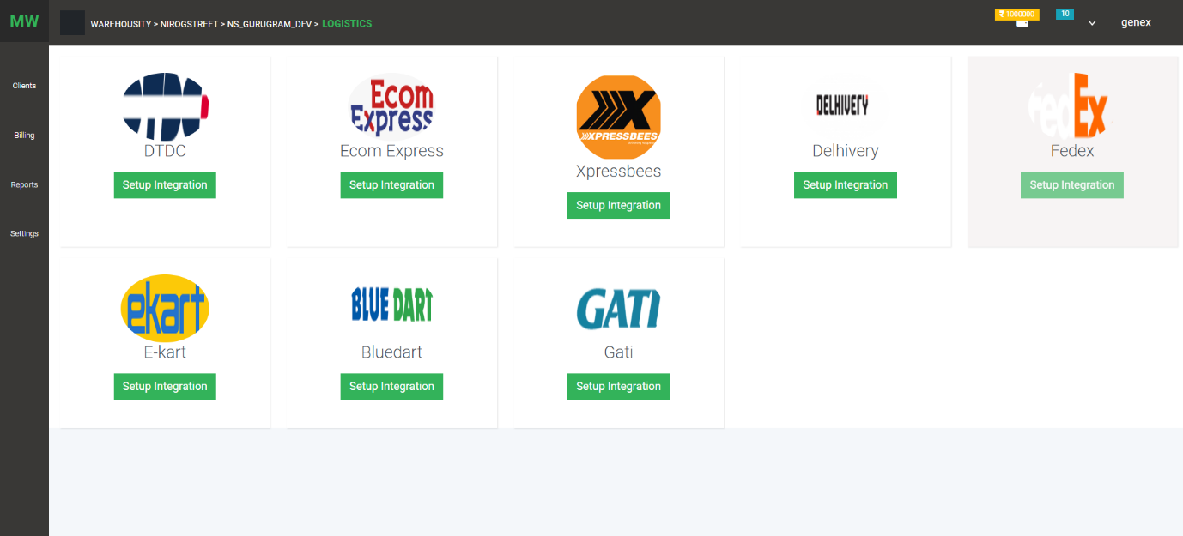

Configuration setup

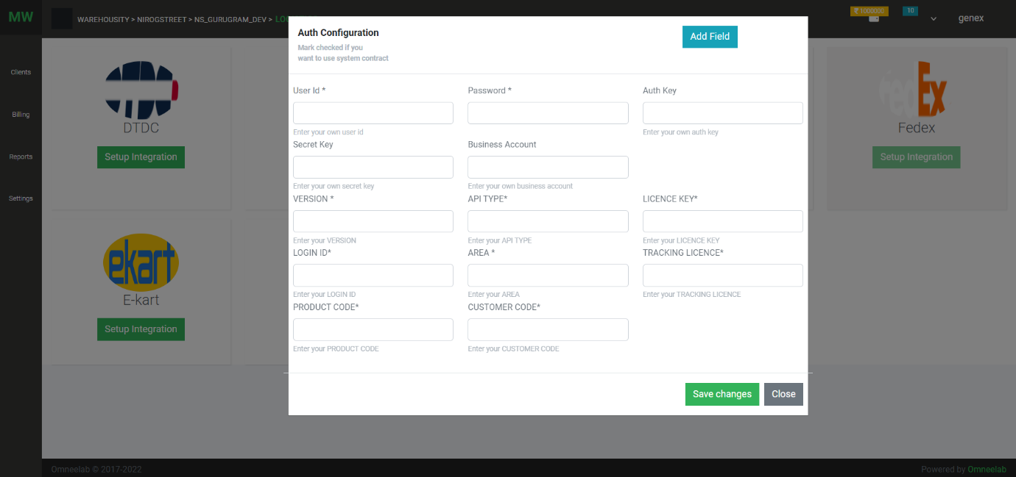

Custom field on configuration screen

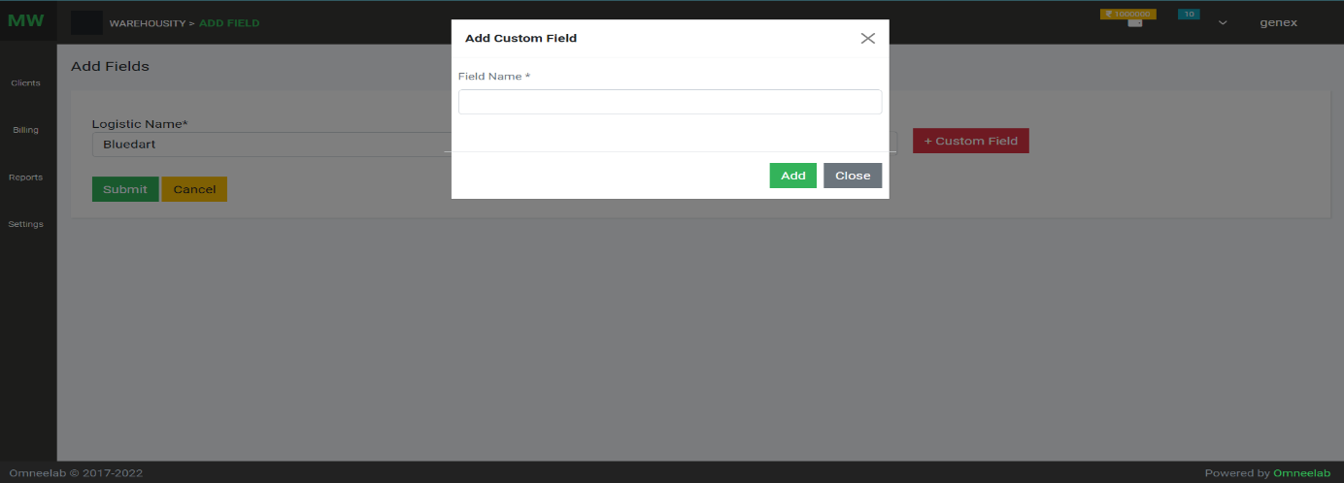

1. Aggregator: list of aggregators

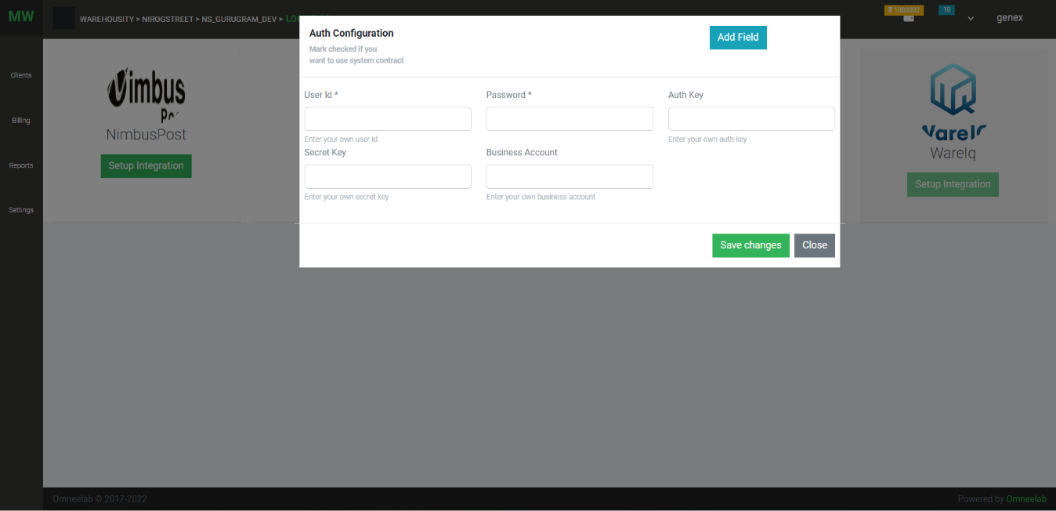List page & Configation setup screen

1. 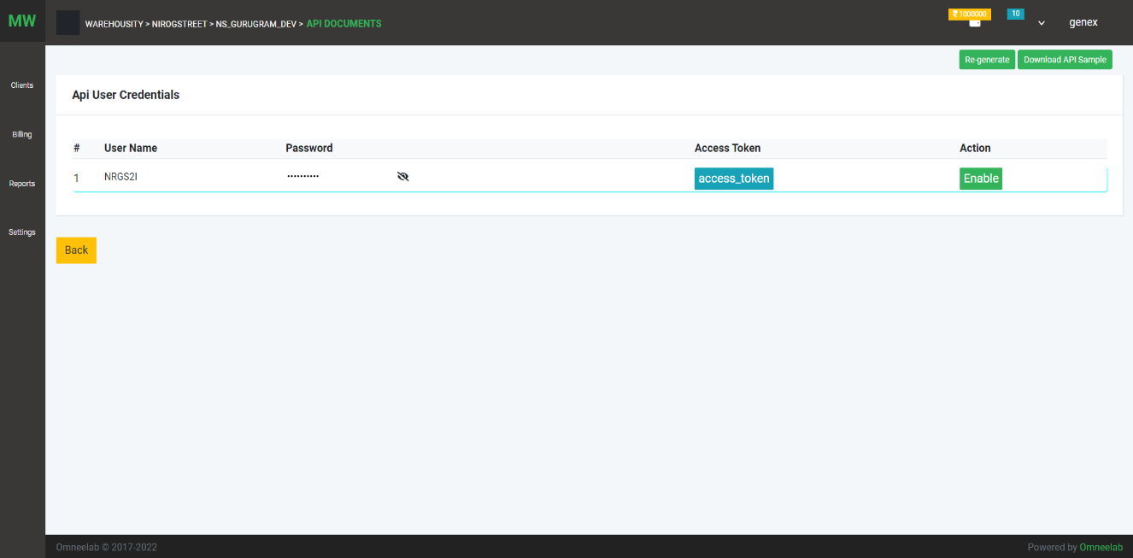API : Api Document and Api user creation and token generation
2. 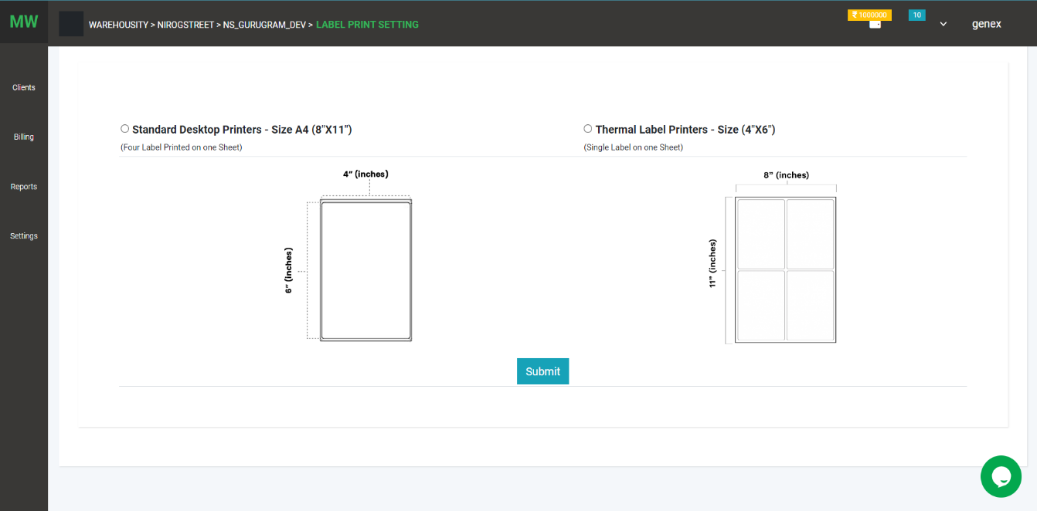Label setting: Use can set label print
3. 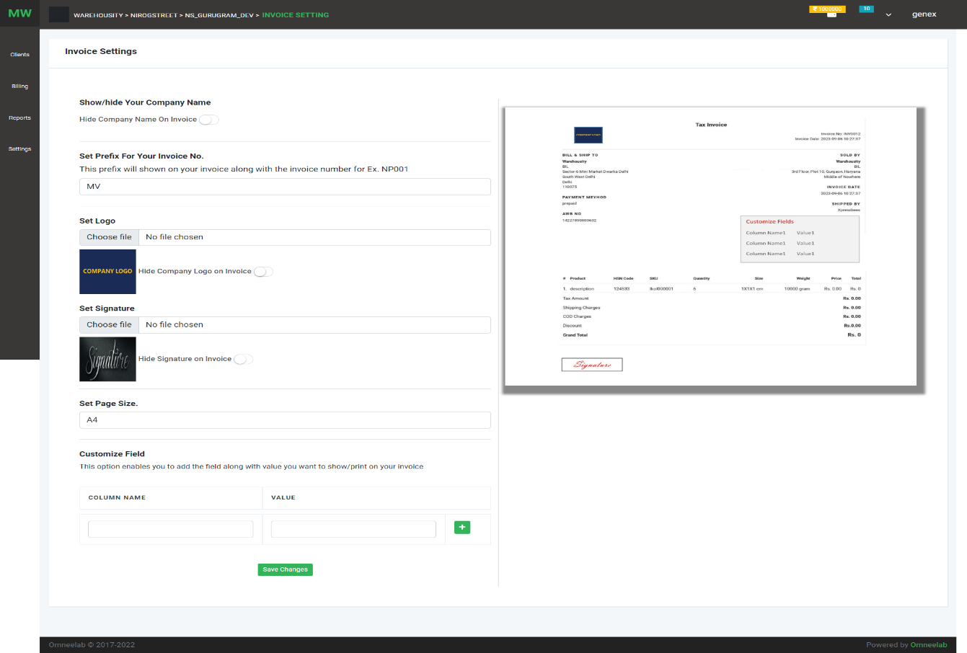Invoice Setting :

On this page, the user can manage invoice settings like show/hide the company name, logo, signature, add custom field. These changes are shown on the invoice

1. KYC:

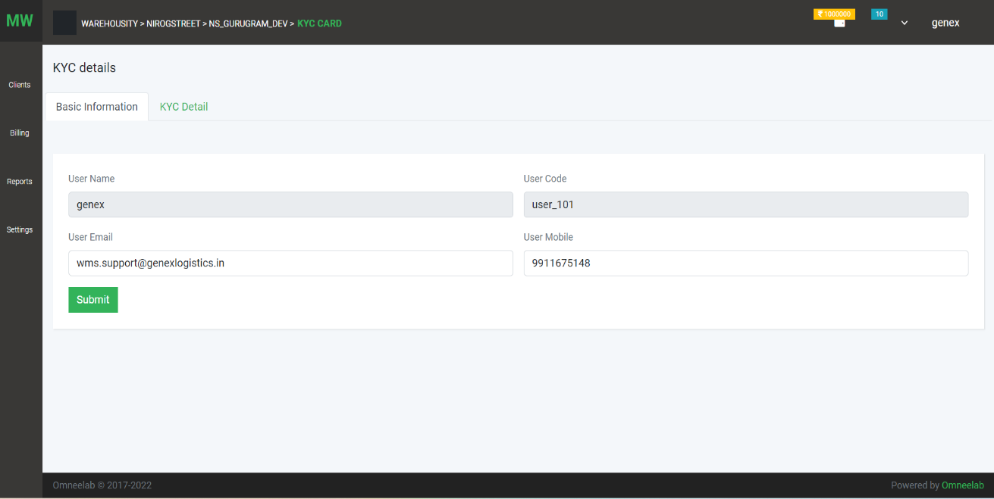On this page user can company basic information like email phone

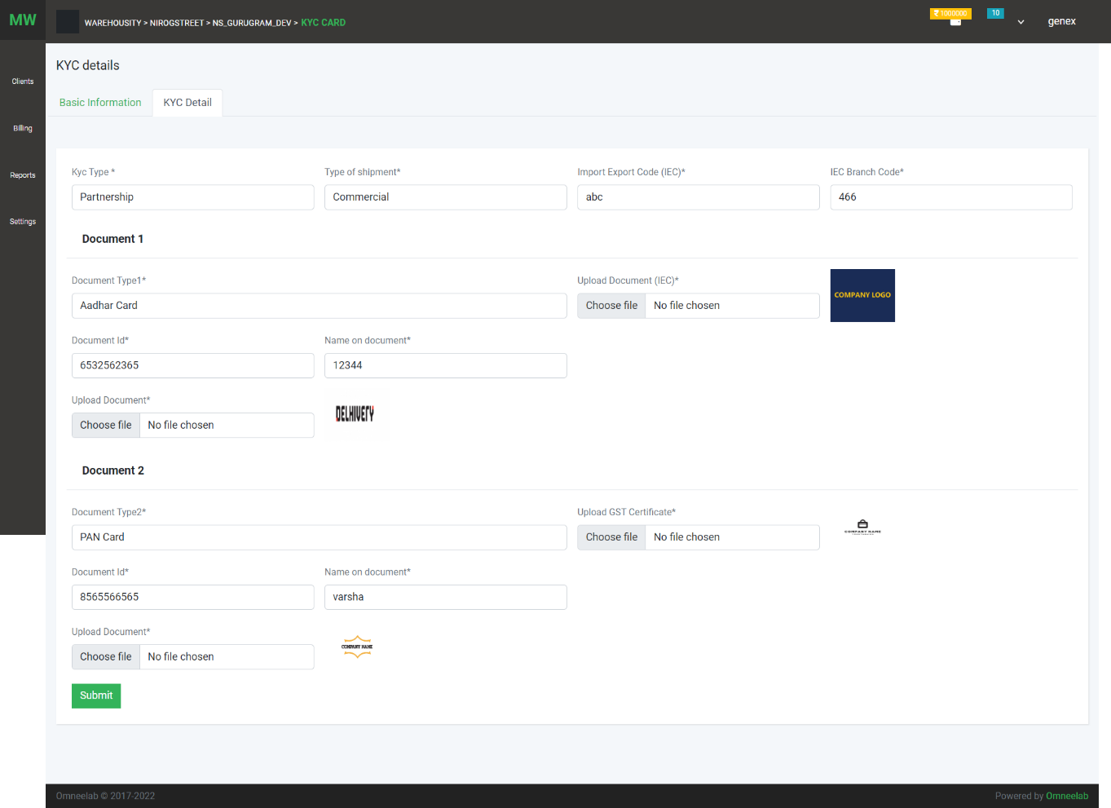On this page user can add or update KYC detail of company

1. WMS: User can add and configure WMS, ERPs, and Unicommerce

List

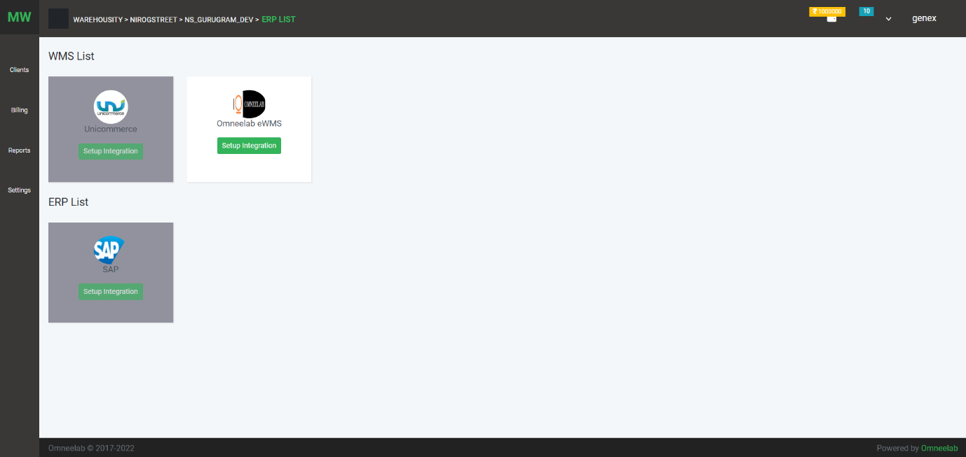

Configuration screen

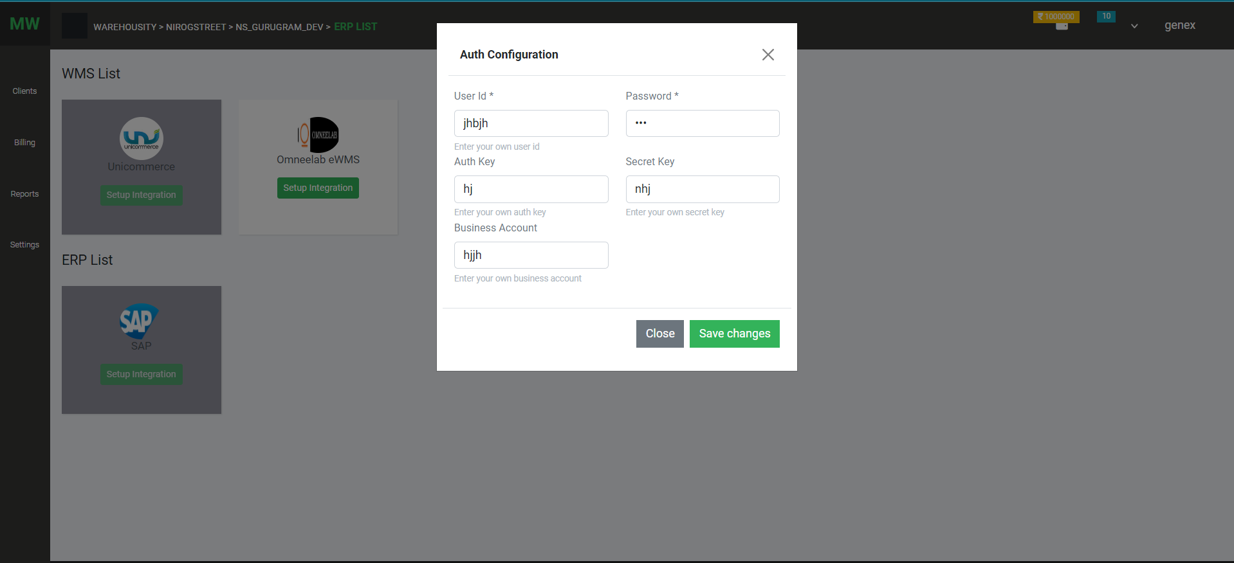

1. Rate Card:

Rate contract

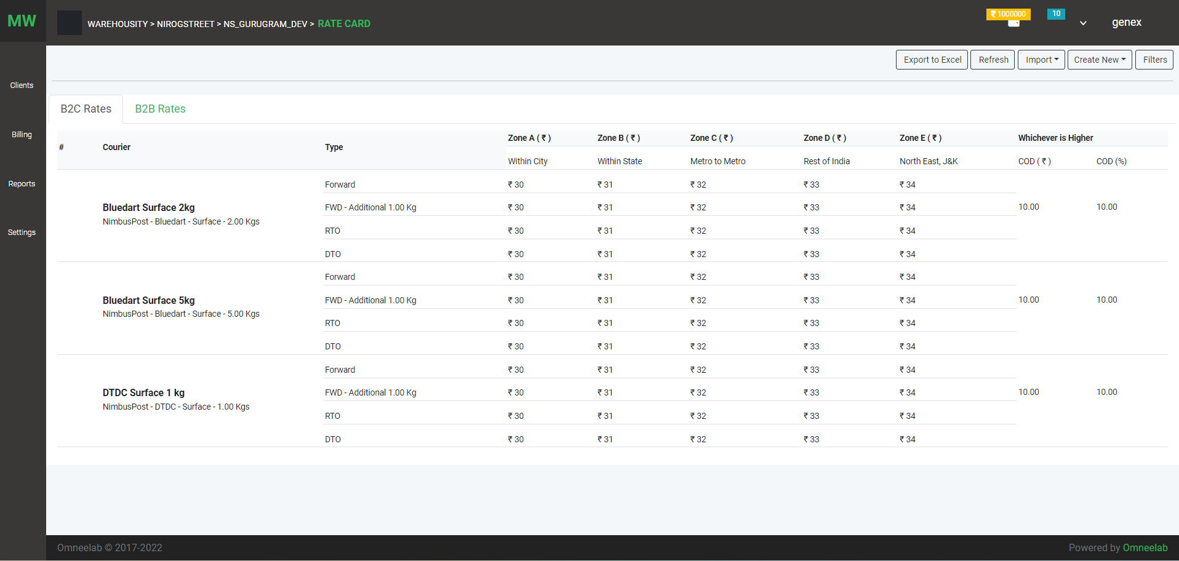

Add Rate Contract Manually

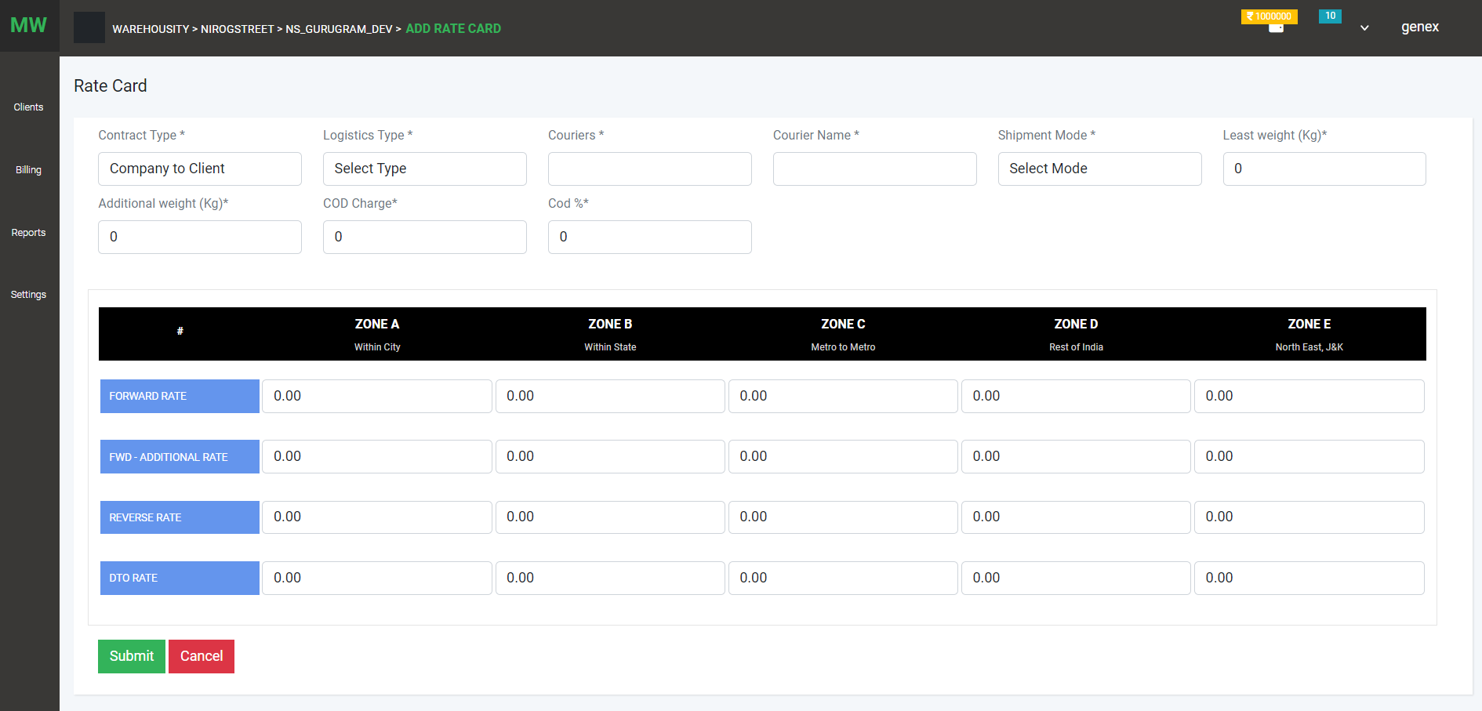

Import option for upload Rate Contract

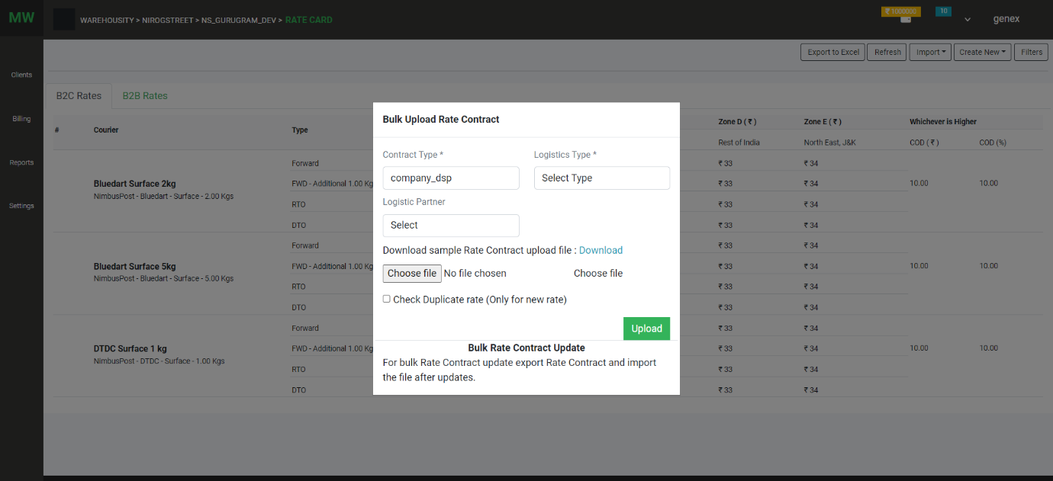

1. Zone: list of zones

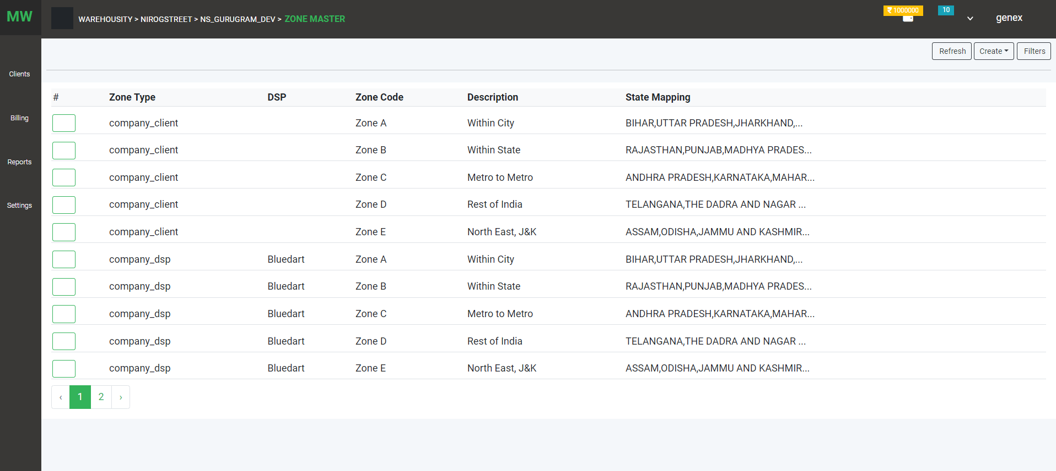

Zone creation

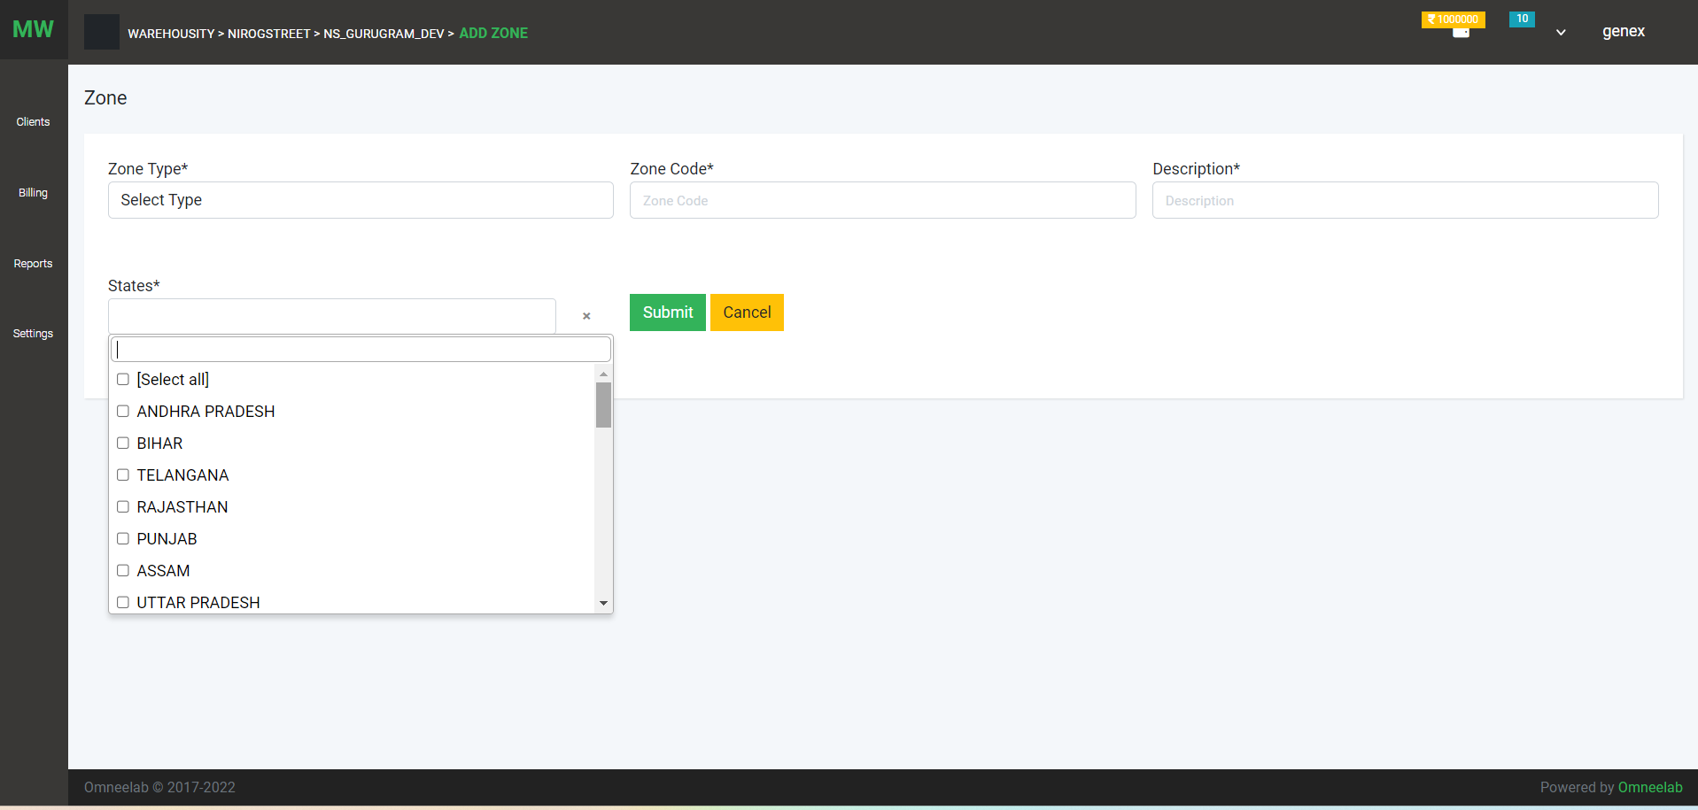

1. Pincode :

List of pincode

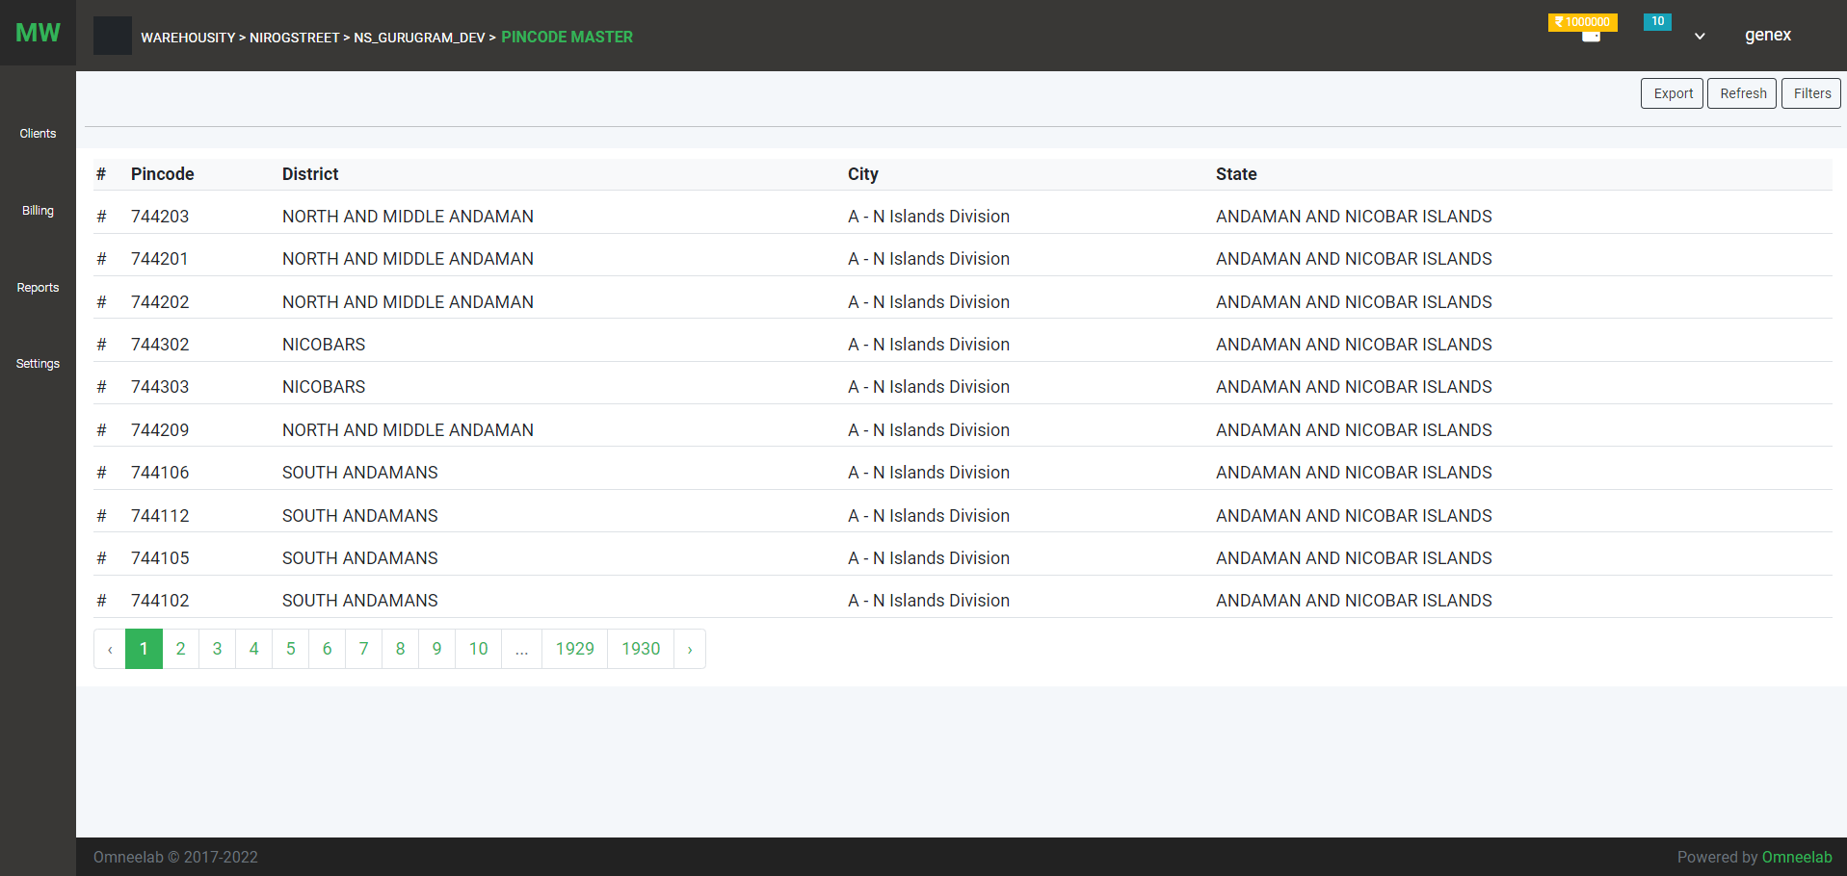

1. Rate Calculator: User can see rate contract and calculate total rate of shipment on particular distance (pick location, destination)

